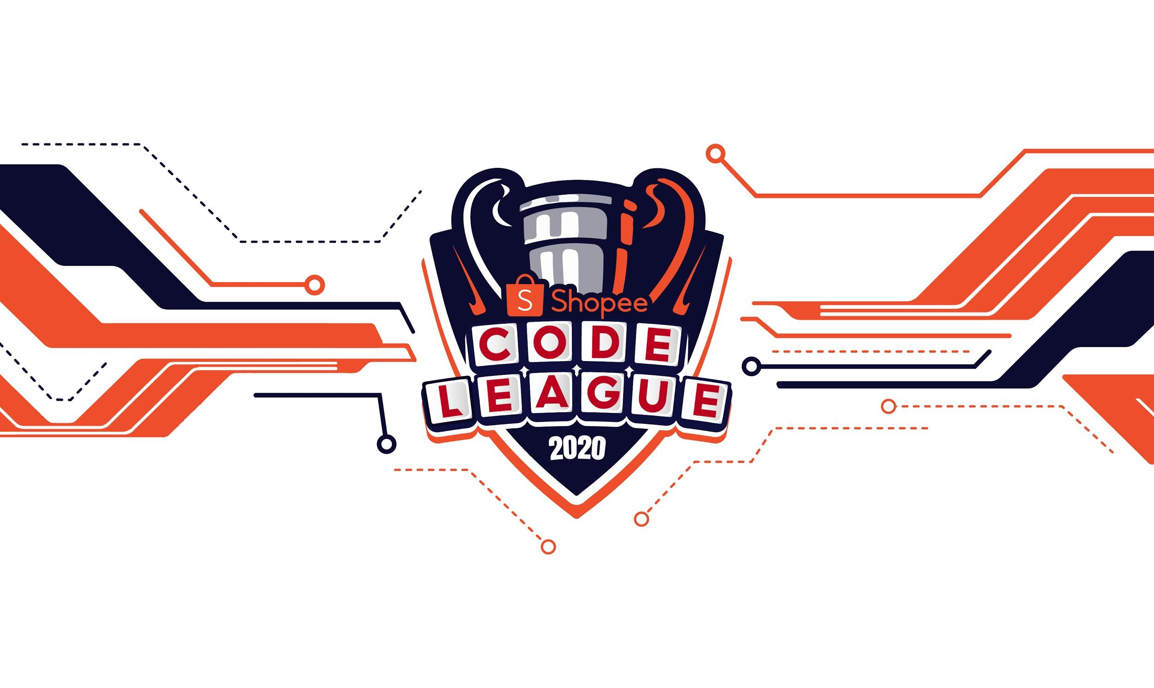

**SHOPEE CODE LEAGUE 2020**

**Product Detection Challenge**

Competition Details

**Start time:** 20 June 2020, 1pm (GMT+7) / 2pm (GMT+8)

**End time:** 4 July 2020, 10.59pm (GMT+7) / 11.59pm (GMT+8)

**Duration**: 2 weeks

Table of Contents

**Product Detection** **2**

Background 2

Task 3

Dataset Description 3

Evaluation criteria 4

Submission File 4

**Competition Rules** **5**

# Product Detection

**Detect Real Product On E-commercial Platform**

## Background

At Shopee, we always strive to ensure the correct listing and categorization of products. For example due to the recent pandemic situation, face masks become extremely popular for both buyers and sellers, everyday we need to categorize and update a huge number of masks items. A robust product detection system will significantly improve the listing and categorization efficiency. But in the industrial field the data is always much more complicated and there exists mis-labelled images, complex background images and low resolution images, etc. The noisy and imbalanced data and multiple categories make this problem still challenging in the modern computer vision field.

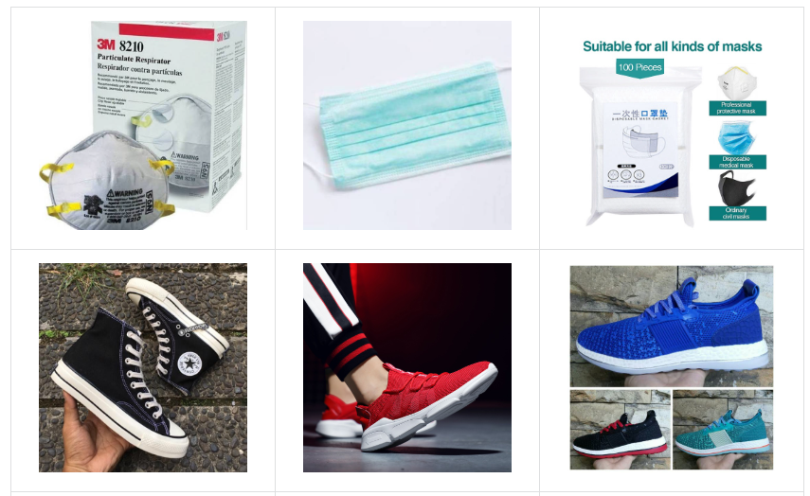

## Task

In this competition, a multiple image **classification** model needs to be built. There are ~100k images within 42 different categories, including essential medical tools like masks, protective suits and thermometers, home & living products like air-conditioner and fashion products like T-shirts, rings, etc. For the data security purpose the category names will be desensitized. The evaluation metrics is top-1 accuracy.

## Dataset Description

In Shopee Product Detection Dataset, there are more than 100k images directly from the E-commercial industry field. You will be able to explore the real-world images which is noisy and long-tailed, and let your model predict the correct categories for the images. There contains 42 most popular categories of products at Shopee.

**File descriptions**

* train.csv: training dataset.
* test.csv: test dataset.

**Columns of data fields**

* filename: image file name(str).
* category: image category(str).

Please download the dataset from the folder.

## 

## Evaluation criteria

Submissions are scored on top-1 precision:

Where

- N is number of test samples.

- xi is the predicted category for i th test sample.

- yi is the ground truth for i th test sample.

- p(xi,yi) is calculated as 1 if xi=yi and 0 otherwise.

A higher score is better. In your practice you need to find a proper threshold to predict category name(string) instead of probabilities.

## Submission File

Submission file format should be `csv` file only. And for each `filename` in the test dataset, you must predict only one proper category name. The `csv` file should contain a header and have the following format:

|  |  |
| --- | --- |
| filename | category |
| 2f096e5e8e8955d43632be16e35993b5.jpg | 0 |
| 3d63a44c82c9d1299b5791bdd2c7a4e8.jpg | 1 |

**IMPORTANT:**  The top 100 teams based on the leaderboard are to submit your complete scripts within 30 mins after each challenge via email to techsg@shopee.com.

# Competition Rules

**Rules**

No sharing outside of teams

Privately sharing algorithms, codes and/or data for the purposes of the Competition, outside of the Participant’s team is not permitted.

No hand labelling of data

Participants are not allowed to hand label Shopee Data (defined herein) provided to the Participants during the Competition Period. Shopee reserves the right to test the teams’ source codes in their respective Entries to verify the authenticity of such Entry. Shopee reserves the right to revoke the teams’ ranking if hand labelling is detected in any Entries of such team.

Team Size Limits

The team size consists of a minimum of 2 to a maximum of 4 Participants per team. Teams with less than 2 members will be disqualified.

External Data

Usage of publicly, freely available external data in the teams’ Entry is permitted.

Eligibility

Employees of Sea Limited are not eligible to participate in the challenge in the interest of fairness.

Entry Requirements

The Competition is open only to registered Participants and Participants can register for the Competition via the Competition Website.

Shopee shall announce the rules and judging criteria of the Competition and any such rules and judging criteria shall be deemed to be incorporated into these Competition Terms and Conditions.

Obligations of the Participants

Participant grants Shopee the right to use the Participant’s name in connection with such Participant’s submitted Entry as well as in connection with any marketing, advertising or promotional material related to the Competition without requiring any further consent or compensation from Shopee.

Participant represents and warrants (where applicable) that it is duly organized, validly existing, and in good standing in the jurisdiction it is formed, that it will comply with all applicable laws in performing under these Competition Terms and Conditions and that it has full capacity, authority and legal right to agree to these Competition Terms and Conditions.

Participants agree that they shall not:

a) use or access datasets provided by Shopee for the purpose of this Competition (“Shopee Data”) for any commercial, gambling, or illegal purpose; b) copy, modify, reproduce, license, sublicense, distribute, transmit, republish, exhibit, or display the Shopee Data (except to the extent copying, modifying, reproducing or displaying is necessary and directly related to the Participants’ participation in the Competition); c) remove, obscure, or modify any copyright notices or other notices, designations, or attributions within the Shopee Data; or d) use any Shopee Marks or any copyright or other proprietary rights associated with the Shopee Data for any purpose without the express written consent of Shopee “Shopee Marks” means all names, trademarks, logos, symbols, designations, emblems, designs, and trade dress of the Shopee, together with all identifications, labels, insignia or indicia thereof.

The winning team of the Competition shall license the winning Entry and the source code used to generate the Entry under an Open Source Initiative-approved license that in no event limits commercial use of such code or model containing or depending on such code.

Intellectual Property Rights

All intellectual property and proprietary rights in each Participant’s Entry shall belong to Participant, save for Shopee’s intellectual property embedded in such Entry which shall remain the sole property of Shopee.

Participant grants to Shopee, its and its subsidiaries’ and affiliates’ agents, contractor and partners, an irrevocable, non-exclusive, royalty-free, worldwide, perpetual and sub-licensable license to reproduce, distribute, transmit, create derivative works of, publicly display and publicly perform the Entry.

Shopee grants to Participants for the Competition Period a non-exclusive, non-transferrable and revocable license to use Shopee’s Data solely in connection with the Competition. Participant shall not, without the prior written consent of Shopee, alter or modify or create derivative works of the Shopee Data or any of Shopee’s intellectual property except as expressedly set forth in these Competition Terms and Conditions.

Nothing in these Competition Terms and Conditions is intended to grant Participant any rights to use any of Shopee’s intellectual property, except as specified in these Competition Terms and Conditions.

Participant warrants that (a) its Entry is their original work and (b) Participant has all rights and ownership or is a licensed user of all algorithms, code and/or data used within the Entry.

Note that these rules are non-exhaustive, for more information please refer to the [Terms and Conditions](https://careers.shopee.sg/codeleague/pdf/terms-and-conditions.pdf) on the Competition Website